**3. Demonstrate how to use Postman with SOAP.**

-We will use newman to demonstrate this:

-Create a new collection, name it as CollectionRun-Newman

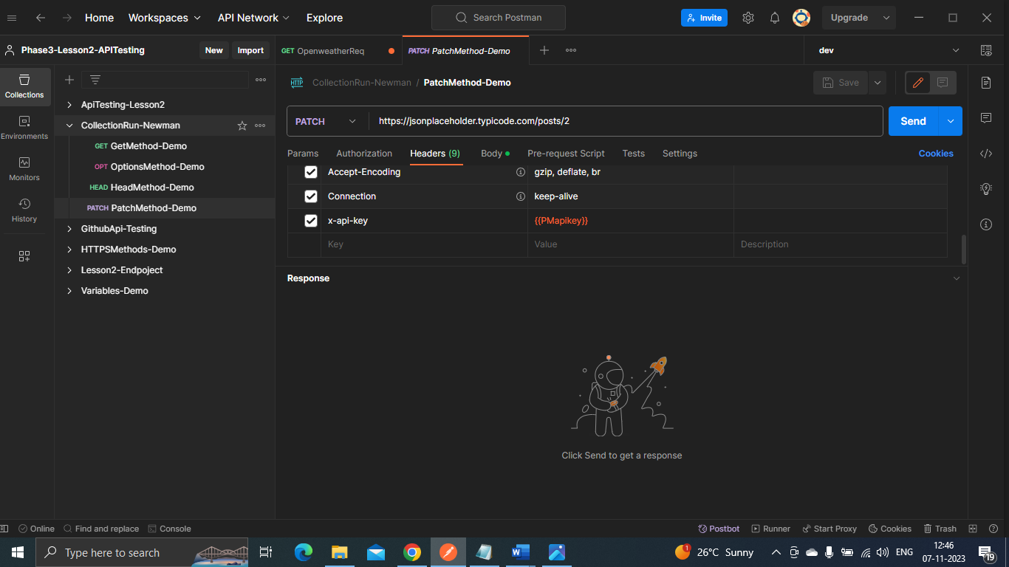-Add methods: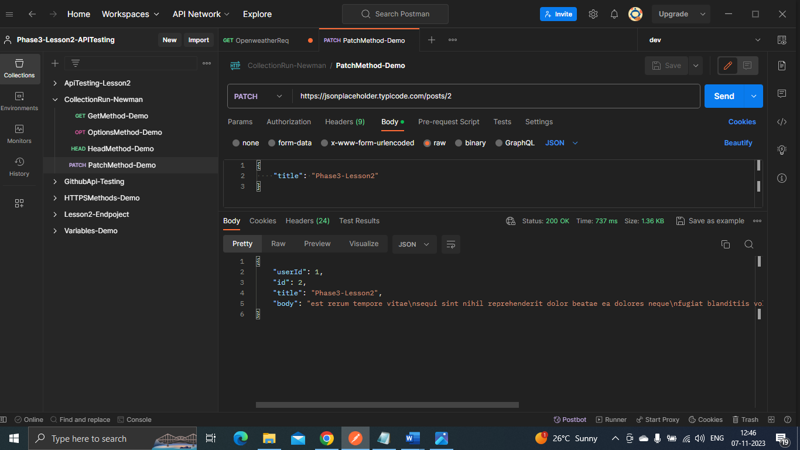-Click on the collection and export the collection to your desktop folder:

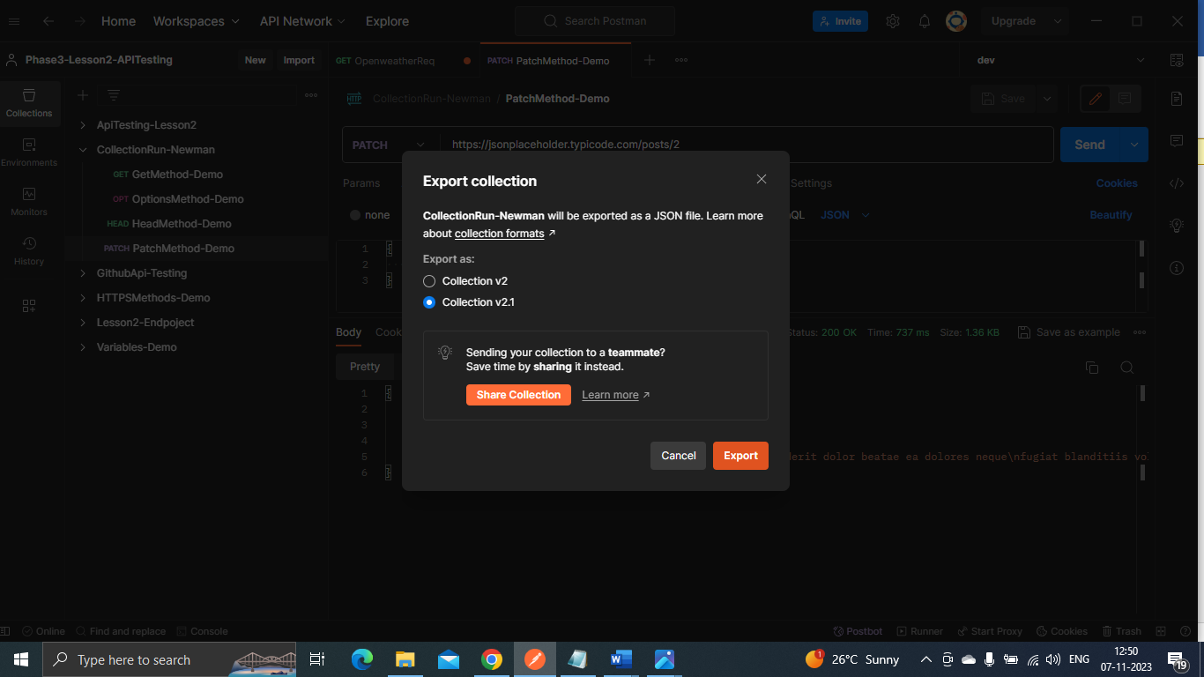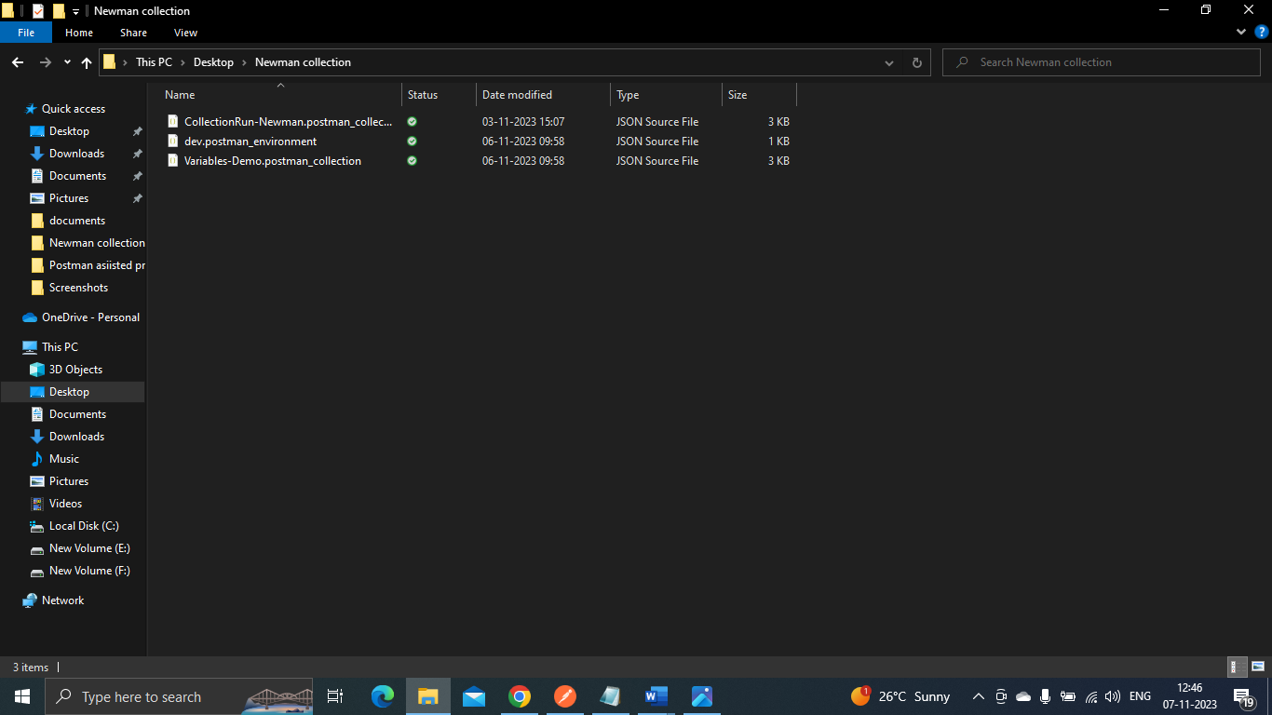-Open cmd on the same folder: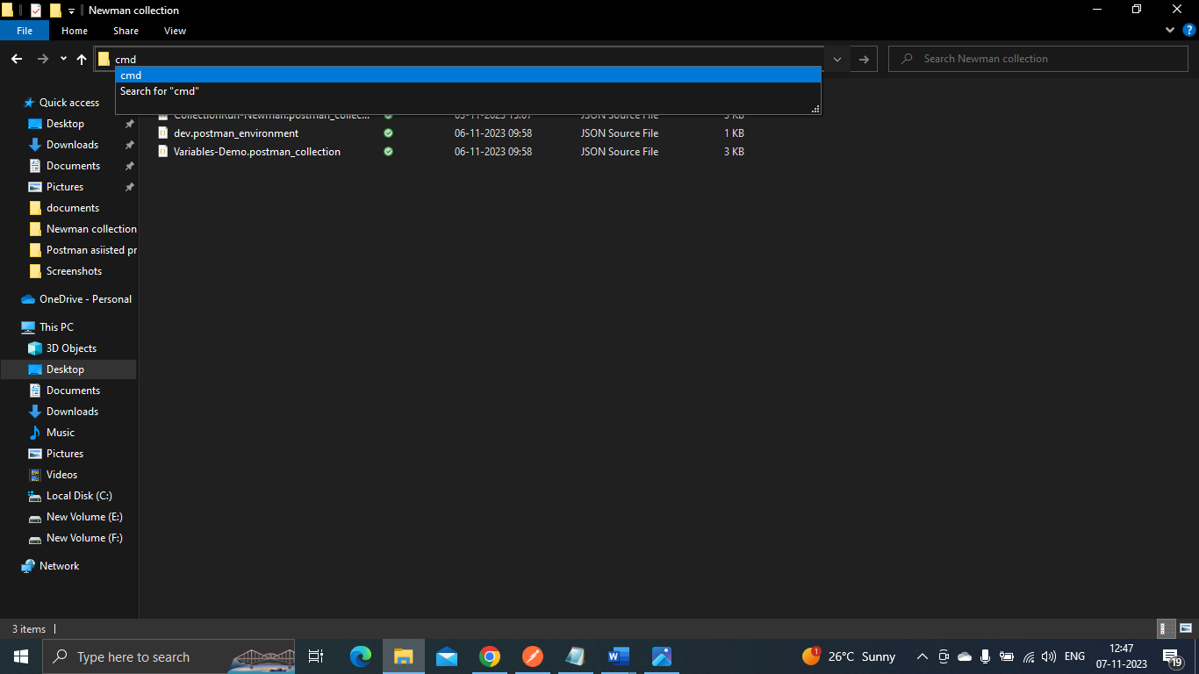

-Now on cmd, run following command, and it will execute:

